Chapter 2: Determine and Configure Hardware Settings

Pseudo file system:

: Pseudo file system location

: /proc -> contain info about running process into system.

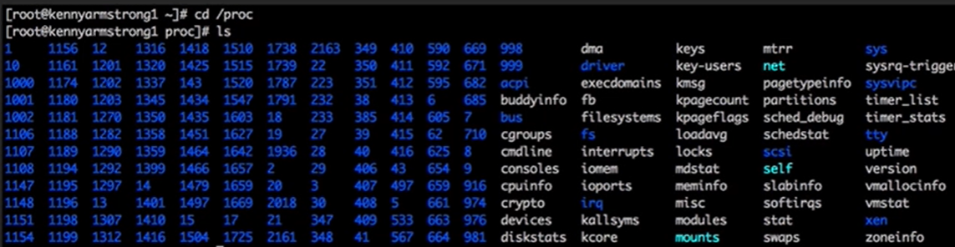

Here number in blue color show process run at time of boot 1(first process)

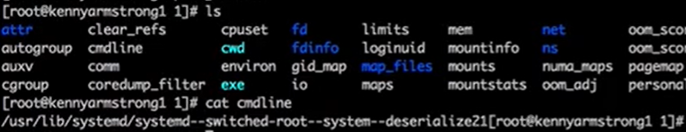

Cmdline file in /1 contain info about cmd which run.

: /sys -> contain info about sys hardware and kernel module.



: /sys/fs -> info about file system

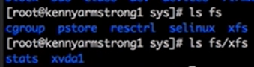

Working with kernel Modules

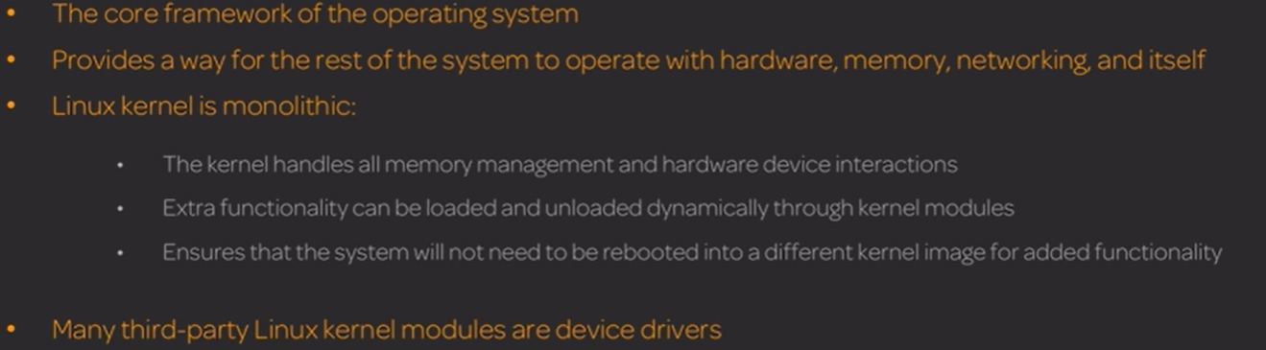

: uname -m (machine info) -rm(release version info) -a (all info) -> basic info about kernel

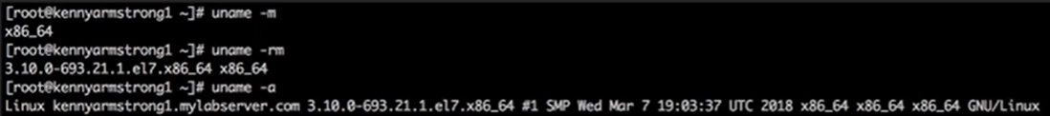

: lsmod -> list all current module 1->running module

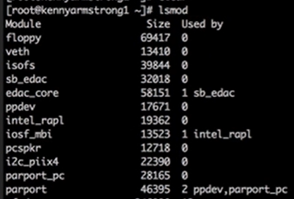

: modinfo <module info> -> give info about module

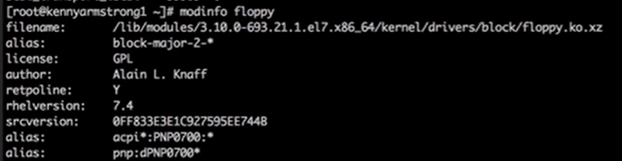

: modprobe -r <module name> -> remove kernel module

: modprobe <module name> -> add module

Investigate hardware

Udev -> detect hardware send it to D-bus and it give hardware info to /dev which check if device is block (lsblk) or not then attach it.

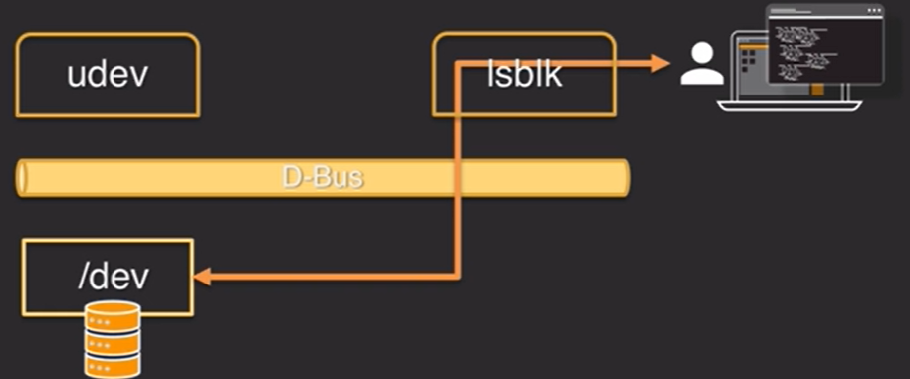

: /dev -> contain info about connected hard drive

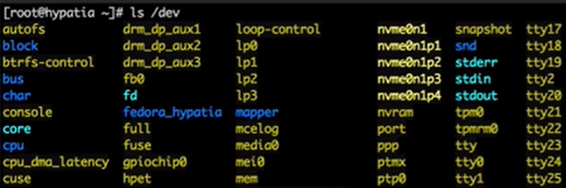

: /dev/cpu -> here we have 8 core so, we have 0-7 directory.



: udev -> device manager for linux kernel

: D-Bus -> udev used to notify system about attach hardware

: lspci -k (info with kernel) -v (more info) -> List pci device

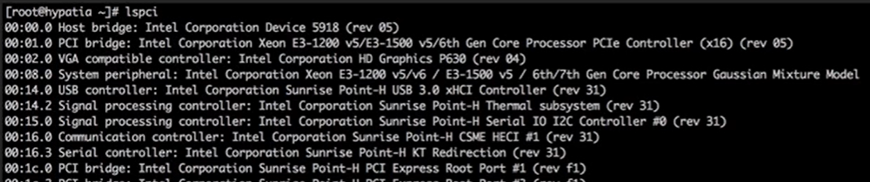

With -k argument

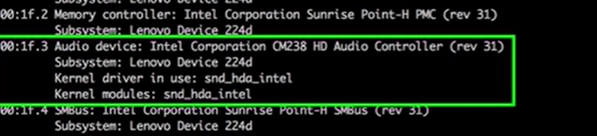

: lsusb -> list usb device

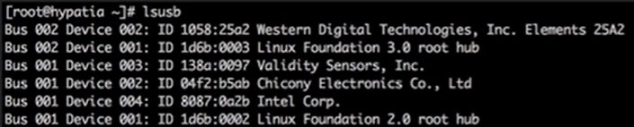

: lsusb -t ->to see tree view

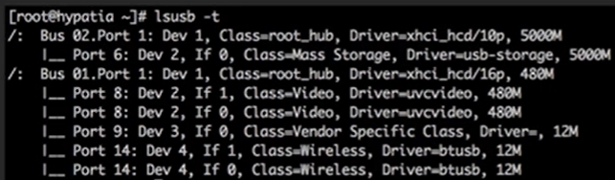

: lscpu -> info about cpu

: lsblk -> info about hardware and block device

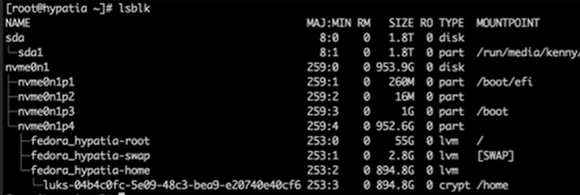

Chapter 3: Boot system

Linux boot process : <https://www.golinuxcloud.com/linux-boot-process-explained-step-detail/>

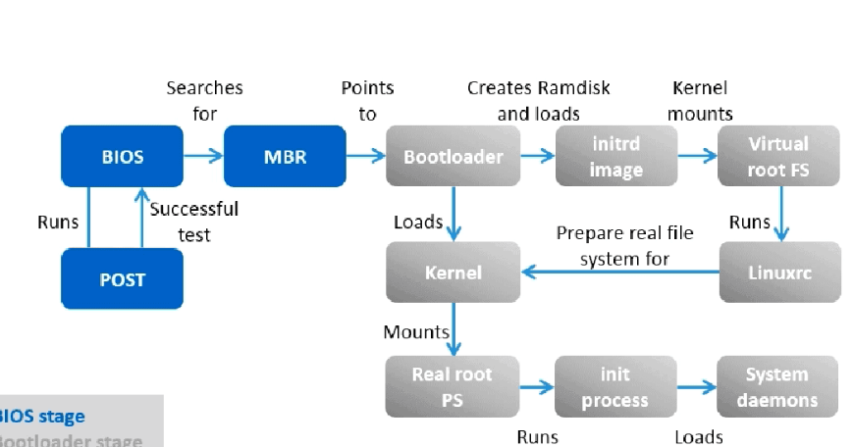

: dmesg -> view is used to kernel boot process or view ring buffer.

: journalctl -k (kernel message) -> kernel message with systemd journal

Init

: /sbin/init -> read config from -> etc/inittab

Run level

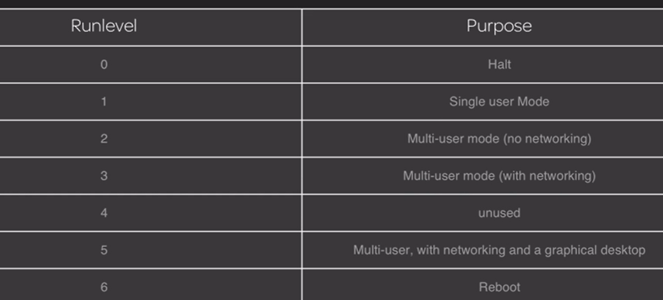

: /etc/rc.d -> location of script to boot system(redhat)

: /etc/init.d -> location of script to boot system(debian) or script for service on the system.

Upstart

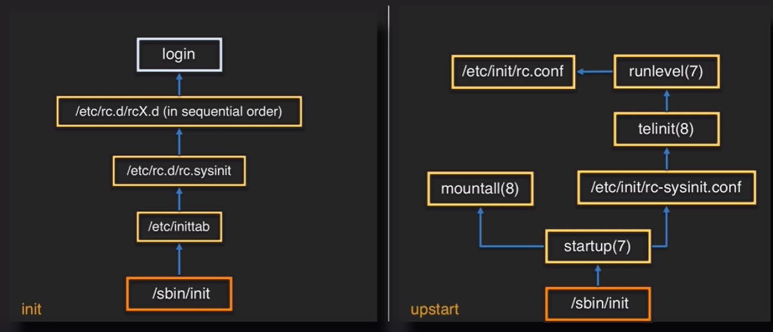

Systemd

Systemd replace the functionality of the shell scripts with compiled c code

Unit file location

/usr/lib/systemd/system -> provided by package installer (this file is not deleted)

/etc/systemd/system -> unit file location for administrator.

/run/systemd/system -> run time unit files location

Component of unit file

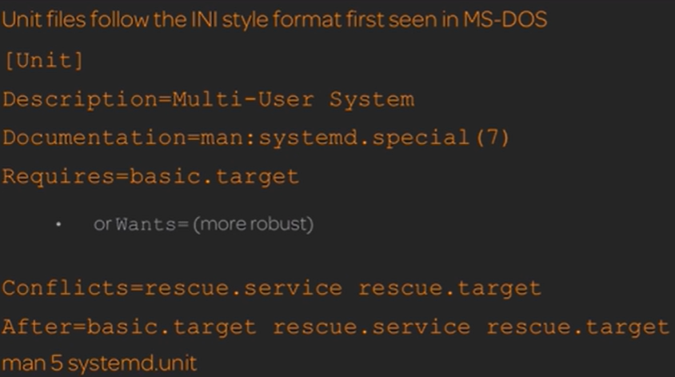

Systemctl cat <unit file name> -> provide content of unit file.

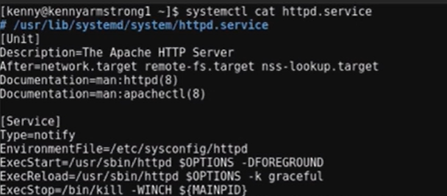

Chapter 4: Change Runlevels/Boot Targets and Shutdown or. Reboot the System

Change working environment

: runlevel -> give info about current runlevel

: sudo telinit <runlevel number> -> to change runlevel

Type of target unit

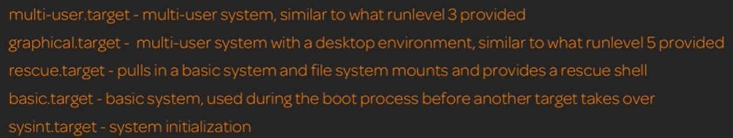

: systemctl list-unit-files -t target ->show all unit file for target

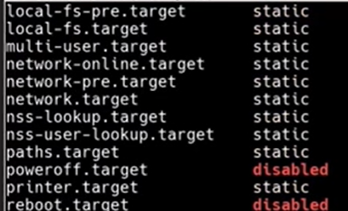

: systemctl list-units -t target ->show all loaded adn active unit file

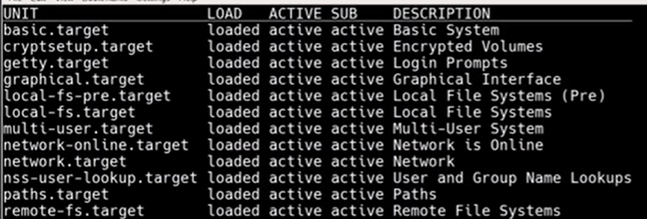

: systemctl get-default -> give info about current target

: systemctl det-default <target name> -> change target



: systemctl isolate <target name> ->change running state from current target to different target

: systemctl reboot ->reboot target

: systemctl poweroff -> shutdown target

Shut down and reboot system

: shutdown -r <time ex. now> -> shut down after time



: wall -> broadcast mess. To all user for quit use ctr+d



Chapter 5: Design Hard Disk Layout

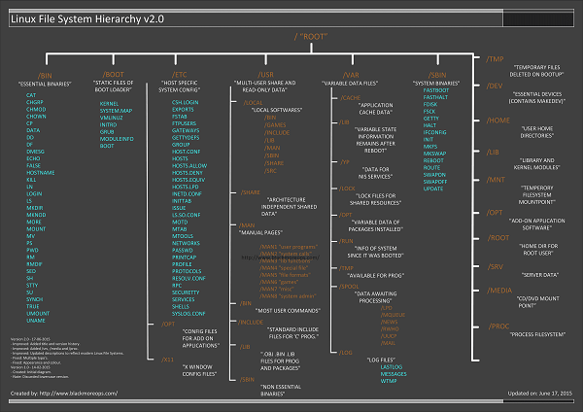

Swap is tem. Storage like RAM

Swap size is 1.5x or 2.0x of RAM

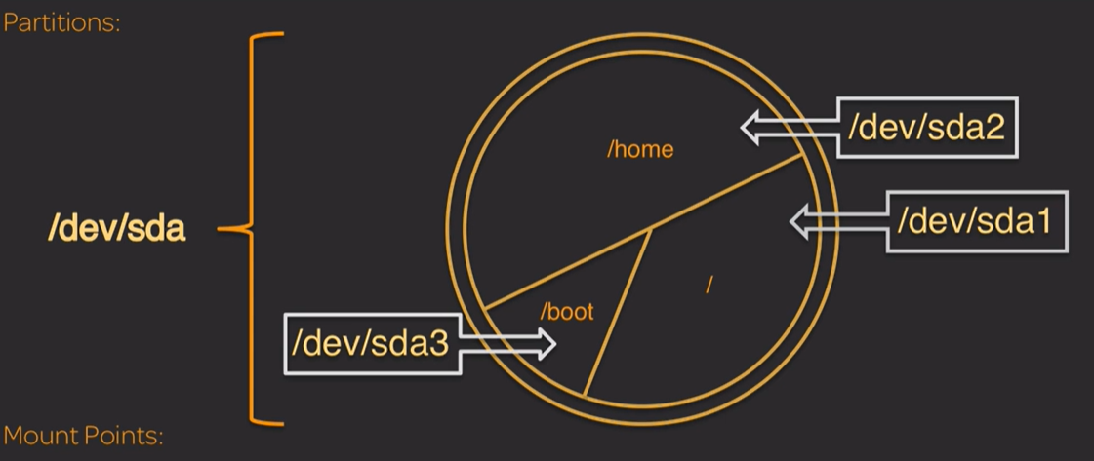

: mount -> used for mount partition to directory

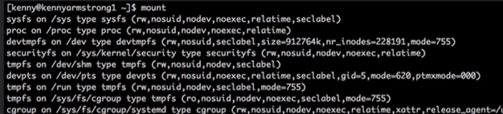

: fdisk -l /dev/xvda ->used to list out partition info on disk.

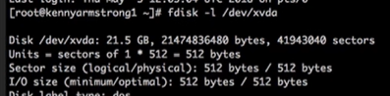

: swapon –summary -> summary of swap partition



LVM (logical volume manager)

: pvs , : bgs , : lvs

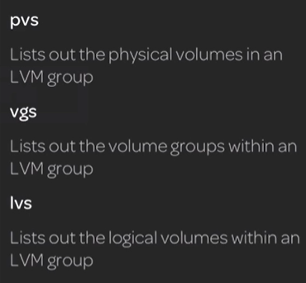

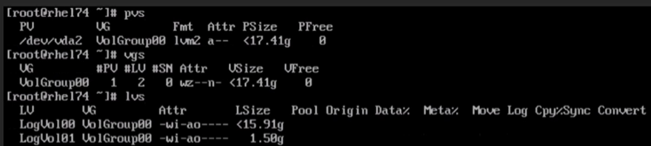

Chapter 6: Install boot manager

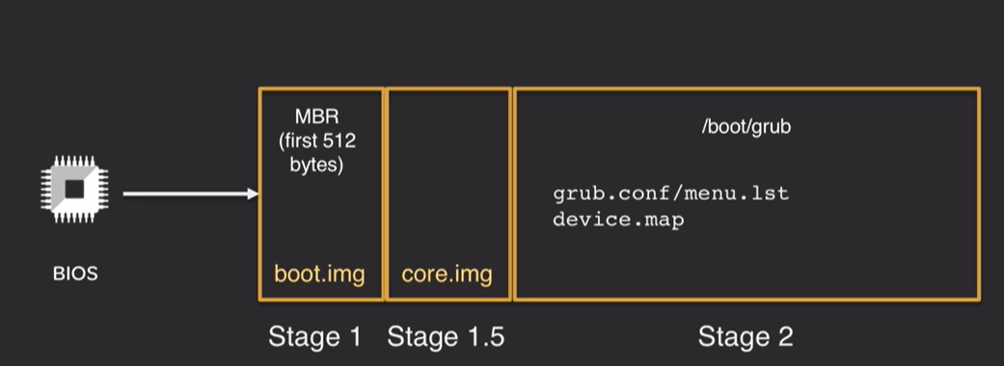

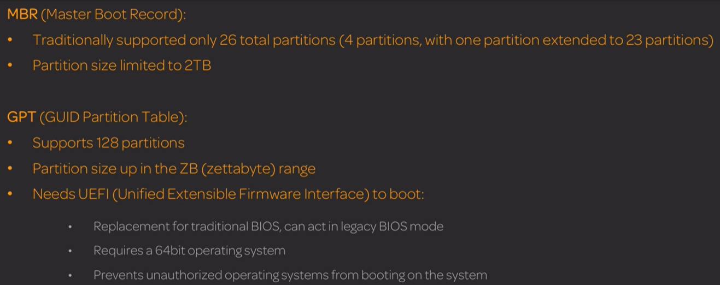

: grub2-editenv -> view the default boot entry for the grub



: grub2-mkconfig -> create or update /boot/grub2/grub.cfg on entry from /etc/default/grub

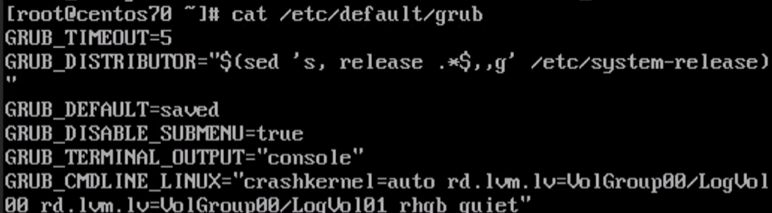

: /etc/grub.d -> config file

Chapter 7: Manage shred library

Shared library object is ends with ‘.so’\

Shred library location

: /lib

: /usr/lib

: /usr/local/lib

: /usr/share

: ldd <library name> ->print out shared library object dependency

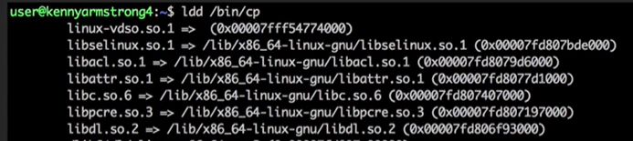

: ldconfig ->create list of currently cached

: /etc/ld.so.conf -> config file that point directory and other config file.

Chapter 8: Use Debian Package Management

: /etc/apt/sources.list -> config file that list out repo location for packages

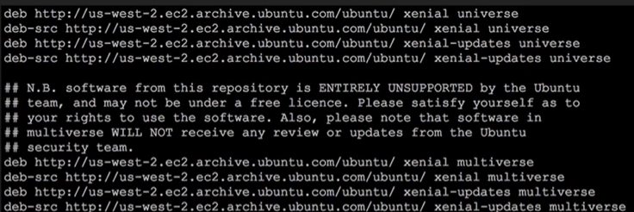

: apt-get upgrade -> upgrade local apt cache

: apt-get update ->update local apt cache

: apt-get install -> install package

: apt-get purge <package name> -> remove package with config file

: apt-get dist-upgrade -> update package on sys up to next realse.

: apt-cache search <package name> -> search package on system.

: apt- cache show -> show info about package

Dpkg

: dpkg –info <package name> -> info about package

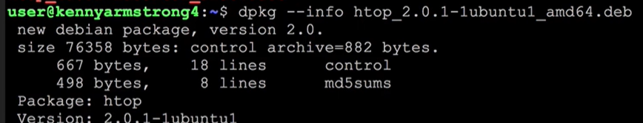

: dpkg –status <package name> -> same as info but less info

: dpkg -l -> list out package that match string provided

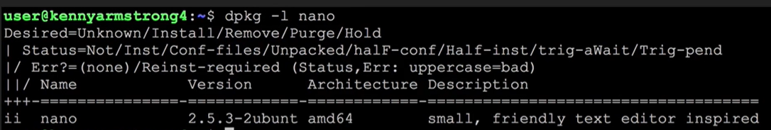

: dpkg -i <package name> -> install package

: dpks -L <package name> -> list file of installed package

: dpkg -r <package> -> uninstall package

: dpkg -P <package name> -> remove config file also



: dpkg -S <package name> -> search package.

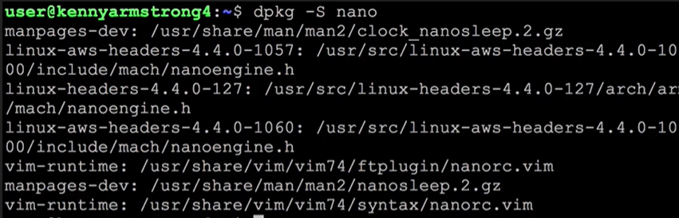

: dpkg-reconfigure ->allow modification of package by rerunning package.



Chapter 9: RPM YUM package management

: yum update

: yum upgrade

: yum search <package name> ->seach package

: yum info <package name> -> info about package name

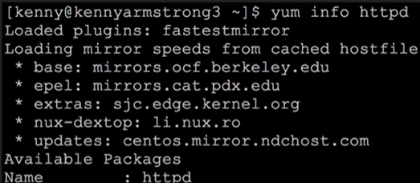

: yum list installed -> list installed package

: yum clean cache -> clean cache info.

: yum install <package name> -> install package

: yum reinstall <package name> -> reinstall package

: yum remove <package name> -> remove package

: yum autoremove -> remove package that yum think we didn’t need



Rpm

rpm –rebuilddb -> repair corrupted database.

: rpm -qpi <package name> -> display info about package

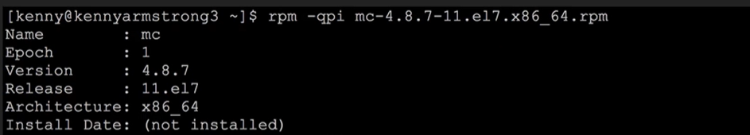

: rpm -qpl <package name> -> list all file of package

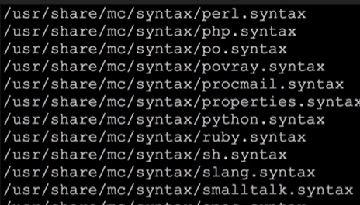

: rpm -qa -> list all installed package

: rpm -i -ivh(for progress bar) <package name> -> install package.

: rpm -U <package name> -> Upgrade package

: rpm -e <package name> -> uninstall package

Chapter 10: Linux virtualization

An entirely isolated set of packages, libraries, and/or applications that are completely independent from their surroundings

Machine container: Shares a kernel and file system with the host computer

Application Container: Shares everything but the application files and library files that the application needs

Examples:Docker , nspawn (from systemd), LXD, OpenShift

Difference between virtualization and container

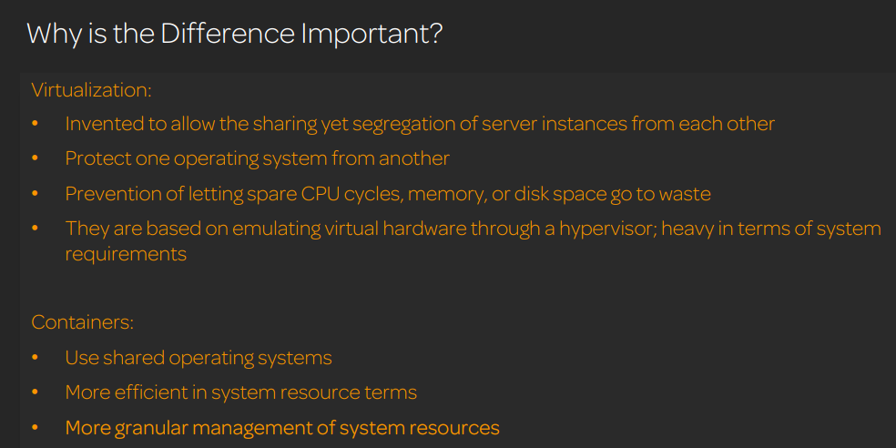

Chapter 11: Work on command line

Chapter 12: Process Text Streams using filters

Chapter 13: Basic file management

Chapter 14: Use steam pipes and redirects

Chapter 15: Create monitor kill process

Chapter 16: Modify Process execution priority

Chapter 17: Regular expression

Chapter 18: Vi text editor

Chapter 19: File system

Chapter 20: Maintain the integrity of filesystem

Chapter 21: Mounting and Unmounting Files system

Chapter 22: File permission and ownership

Chapter 23: Soft and hard link

Chapter 24: FInd file and place files in the correct location.